2 Minute Form
Trip Name: Hatfield’s to Te Muri
Check-in Name and Phone:
Date: Branch:
Leaders
Cell Phone Number
VHF Call Sign &/or Vessel Name
Vehicle make, model, registration, colour
General Plan
Note: If plan changes, you must notify your Check-in person.
Latest Time Off the Water |  |  |  |  | TMP/ AMP used²⁰
Tide/ Forecast Lake Level | Low |  |  | High | Other
Communications Carried²¹
Communications | We will be communicating as a group on VHF Channel
Equipment Carried
Trip Report
(Use other side if more space required)

Activity | Club trip | Centre | Auckland | Location |  |  |  |  | Difficulty¹ |  |  | Beginners
Activity Description | Launch at Hatfield’s Beach, paddle along the coast to Te Muri. Return |  |  |  | Leader qualification req.² |  | Trip Leader
Get in Location | Hatfield’s Beach |  |  |  | Chart/ Map no.⁴ |  | 532 |  | Distance |  |  | 13 km
Get out Location | Hatfield’s Beach |  |  |  | Coastguard Channel |  | 82 & 16 |  | Nowcasting |  |  | 21
Emergency get out ⁵ | Waiwera, Wenderholm |  |  |  | Emergency / Coastguard Station |  | Auckland |  | Phone |  |  | *500  09 303 4303
 |  |  |  |  | Drinking Water⁶ |  |  | Toilets⁷ |  |  | Flush toilets at Hatfield’s; long drop at Te Muri
Emergency Response | Refer Emergency Response Booklet |  |  |  |  |  |  | Parking⁸ |  |  | Hatfield’s
Specific Equipment Required⁹ | Normal Paddling gear |  |  |  | Working Communications equipment in this area¹⁰ | Cell phone Sat Phone |  |  |  |  |  |  | VHF  PLB
Other resources  and notes¹¹ | At Te Muri, depending on the tide, there is the possibility of practicing ferry gliding on the river at the northern end. This is slow moving with no rocks etc, but good enough for new paddlers to get the idea and learn something.  There is no vehicle access to Te Muri – foot and water access only. |  |  |  | Weather Parameters¹² | Beginners Wind under 15 knots, no significant surf or swell  Intermediate Wind under 25 knots, and surf or swell less than 1.5 metres  Advanced Any condition that is suitable for the trip's aims
Previous incidents¹³

Safety Management¹⁴
Hazard |  | Significant? |  | Management Strategy¹⁵ |  |  |  | Hazard | Significant? | Management Strategy¹⁵
Cold Water |  | Yes |  | Carry spare dry clothes and shelter |  |  |  | Deep Water | Yes | Correctly fit PFDs
Medical Conditions |  | Yes |  | - Leader has first aid qualification  - Ask customers about medical conditions |  |  |  | Bad Weather | Yes | Understand weather forecasts.  Have back up plans or pull out if necessary
Capsizing |  | Yes |  | - Correctly fit PFDs  - Skills at performing rescues. |  |  |  | Heat / Sun | Yes | - Protective Clothing (worn)  - Sun Screen  - Plenty of drinks  - Sunglasses
Panic |  | Yes |  | Ensure conditions match level  of skills |  |  |  | Obstacles | Yes | Awareness of reefs, navigational hazards, nets
Road Crossing |  | Yes |  | At Hatfield’s there is a toilet block on the opposite side of the very busy open road. Take extreme care when crossing the road. |  |  |  | Other Vessels | Yes | - Understand the “rules of the sea”  - “Be seen” – Have two of the following; flag, brightly coloured kayak, brightly coloured Pfd or hat. At night: an all round white light & a powerful torch.
Surf Landing |  | Yes |  | If there is a swell, there is often a small surf at Te Muri. Ensure that participants have the required skills, or land/launch one at a time with assistance. It is usually sheltered at the northern end of the beach.
Written up by: | Larraine Williams |  | Approved By: |  | Russell Williams | Signed: | RW |  | Date: | 20 April 2014 | Review in: | 12 months from date of approval

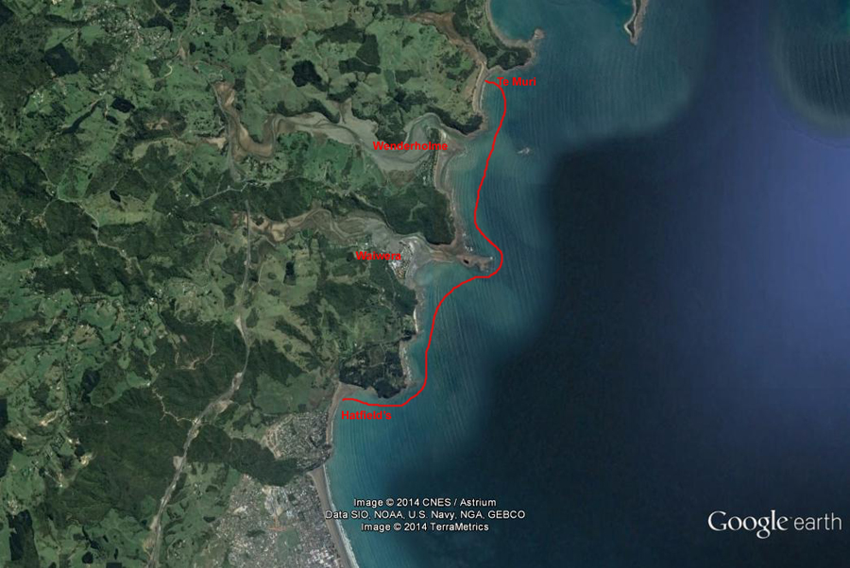
Additional Information Sheet (Optional)
Introduction (A general introduction)
Description (A description of the tour – as if you were selling the idea to someone)
Local Attractions |  | Transport/ Local Operators
 | Contact details |  | Contact details
Local Eateries
 | Contact details
Accommodation/ Campsite Locations |  |  | Facilities
Name |  |  | Cabins |  | Fuel
Phone |  |  | Showers |  | Power
E-mail |  |  | Toilets |  | Water Access
Website |  |  | Laundry |  | Pool
Physical Address |  |  | Water |  | Fires Allowed
Other |  |  | Supplies
Other information

